Meno a priezvisko:_________________________________________________Hodnotenie:_______________________
- Popíšte:
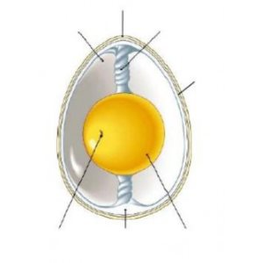

- 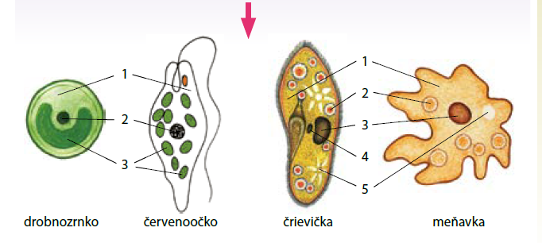

________________________ ______________________________

3.


_______________________________ ______________________________
Meno a priezvisko:_________________________________________________Hodnotenie:_______________________
- Popíšte:


- 

________________________ ______________________________

3.


_______________________________ ______________________________

